

smilechildcare's Newsletter August 2026
We would like to welcome back all our term time families, we hope you have had a lovely holiday. And say a big hello to all our new families joining us in both the Nursery Class and the Little Learners.

We have been busy over the summer
Throughout the summer period we have said goodbye to lots of our children leaving for primary school and their families. Because the rooms were quieter, we were able to join them together, allowing the younger children to experience play with the older children, explore different play spaces supporting them to build confidence in relationships, which in turn will allow for an extended gentle transition.
Our younger children have really enjoyed the opportunities this gave them to be creative in the playrooms and build their confidence in play in the big garden. It has been lovely to see all the children building friendships, with the older children talking a mentoring role with the little ones, spending lots of time in our gardens as the weather was so good.

We have made some changes to our play spaces in both rooms to support the variation in age of the children, to ensure curiosity and challenge, for them all.
We have also begun to create a quiet, calming space for children to use to allow for relaxation, chill out times and quiet play. I look forward to sharing this with you all at our next stay and play evening.
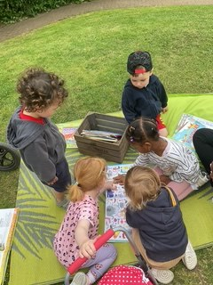
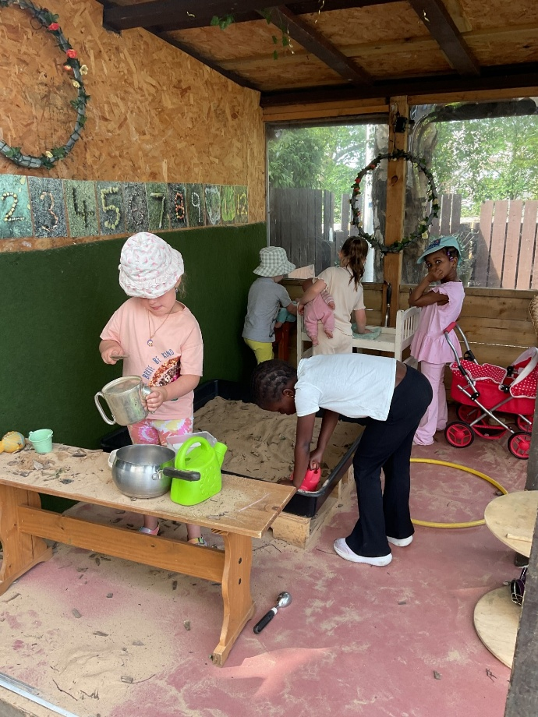

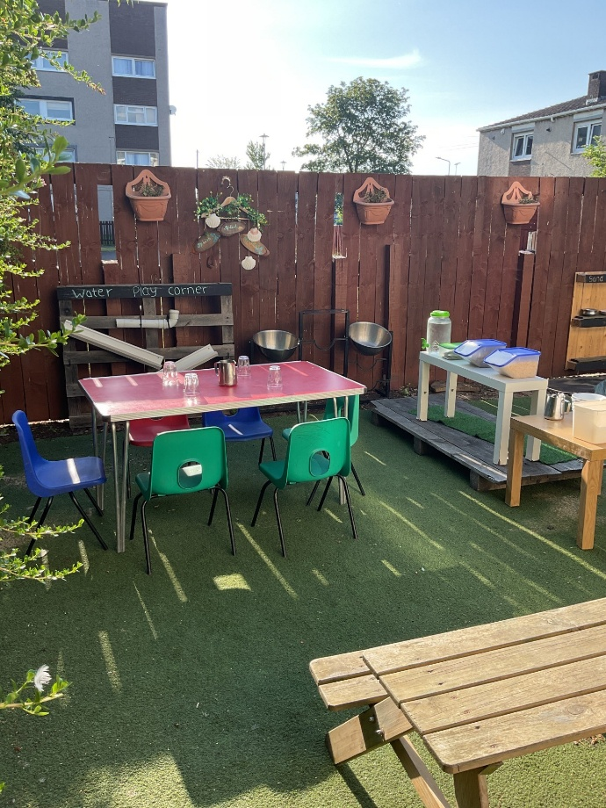
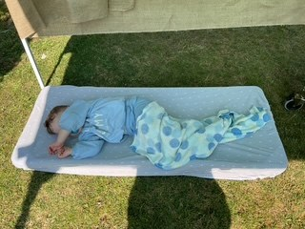

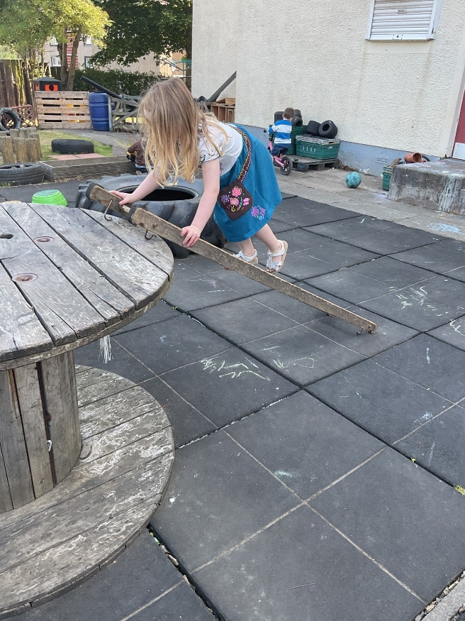
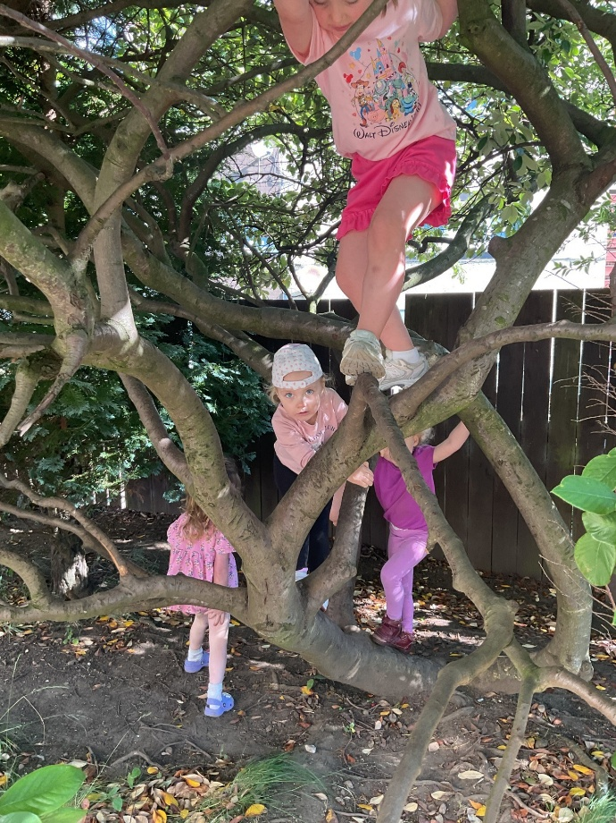

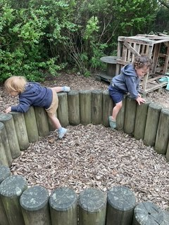
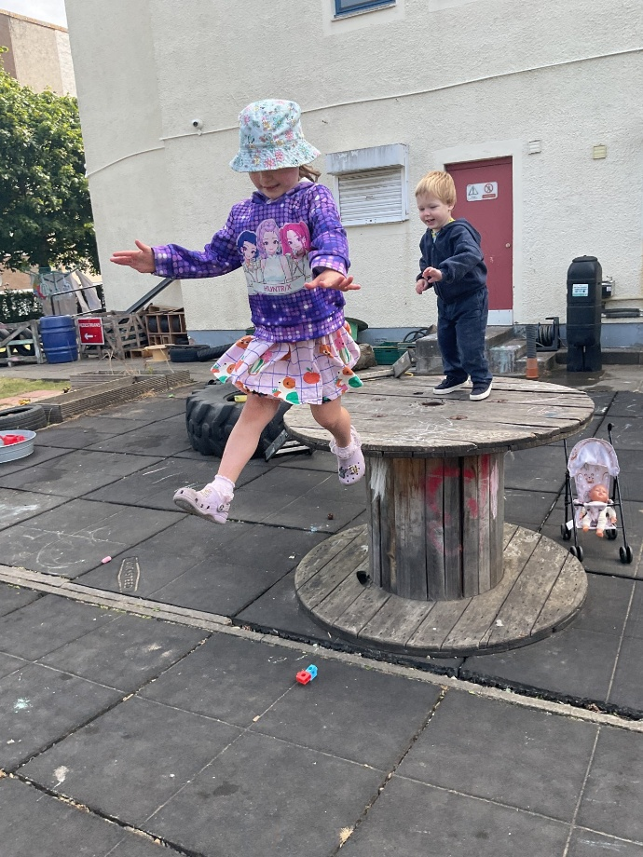
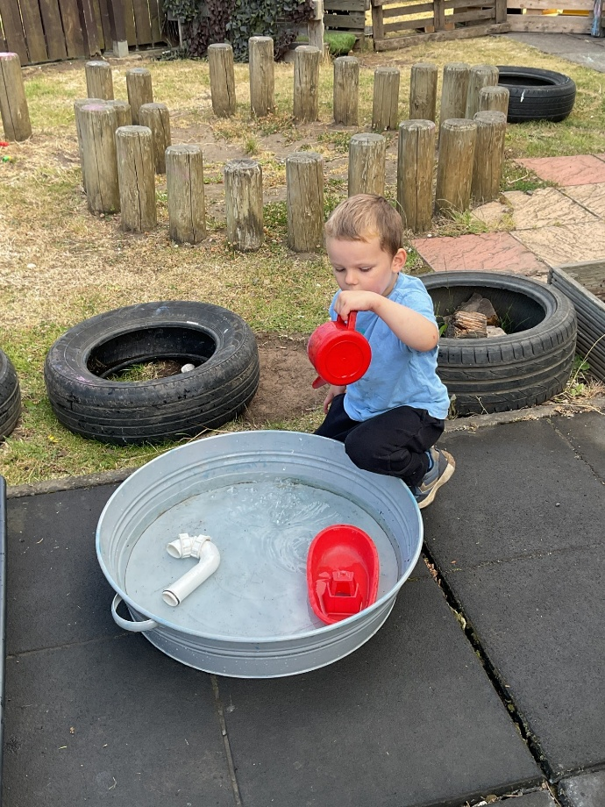

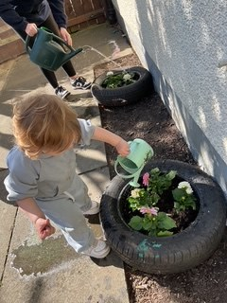

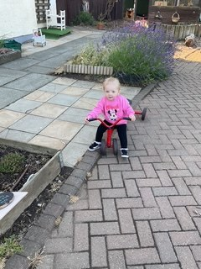
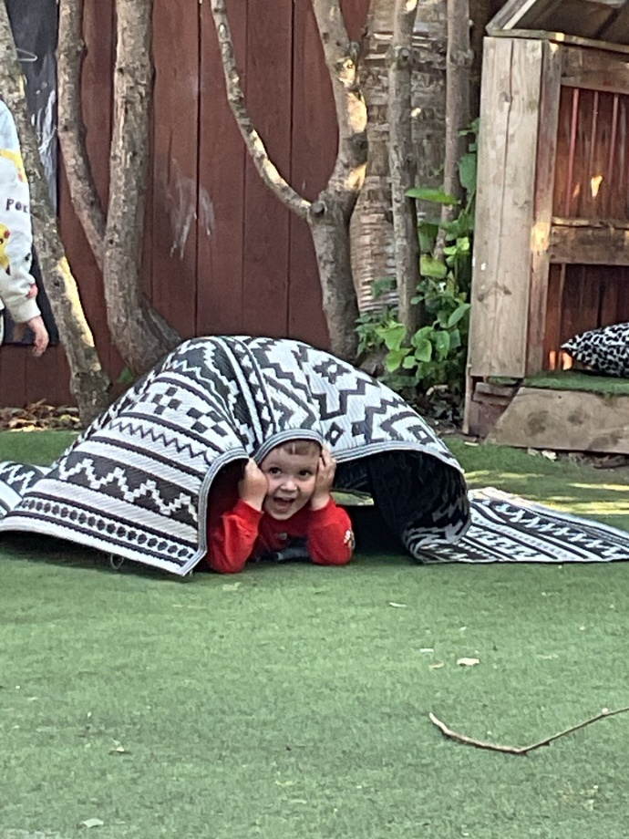

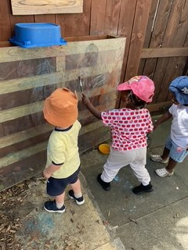
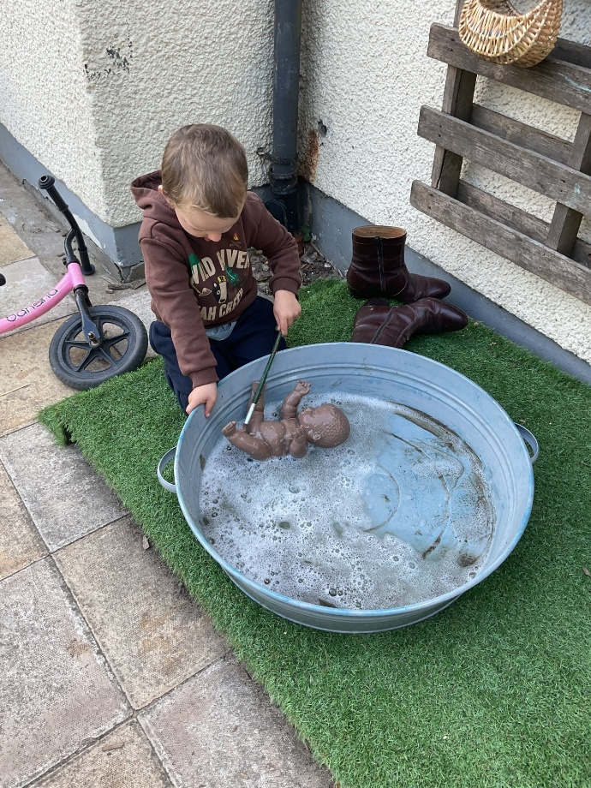
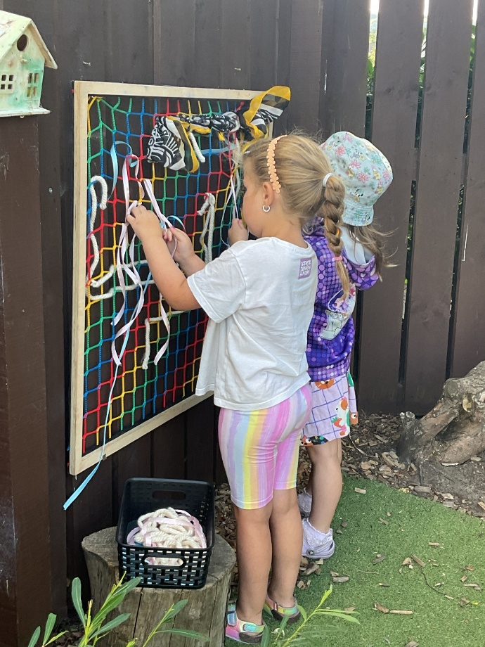
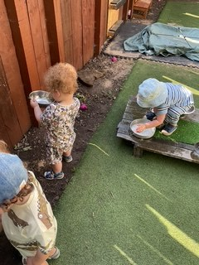

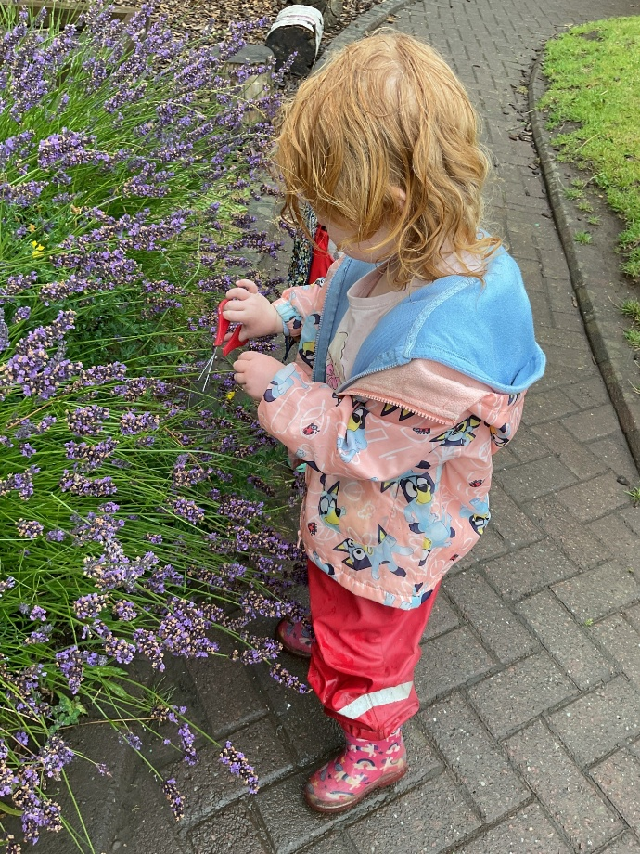


Learning Journals
Every child has their own learning Journal; we strongly encourage all parents to spend time exploring this resource. We love to see what you and your child have been up to at home, and please do share your thoughts on the information shared with you from the practitioners.
Please see the below link for support in how to use this system or speak to Dawn Moorehead who will be happy to help.
How To Videos - Learning Journals
Each term staff will observe and track your child's learning and interests, from this your child has priorities the staff will have shared with you. You can expect at least 1 tracked observation on each of these priorities throughout the term as well as daily updates on what your child has had for lunch.
Staff will also share stories about the children, letting you see some of the fun they are having whilst in nursery.
Whilst we understand parents like to see and hear more of what happens daily, sadly, this is not achievable, but staff will ensure a full daily hand over.
Please do speak to staff if you have any other questions about your child's time at nursery.

We would also encourage all families to interact with these observations and stories as this lets us know your thoughts, or if you have any questions. As well as sharing news from home with us.

Outdoor ready

It is our intention to offer outdoor play in all weathers, allowing children to explore and enjoy the elements. Please check the list below, as this will support you in dressing your child appropriately to enjoy their outdoor experiences.

What to wear in Autumn/winter
- Waterproofs
- At least 2 pairs of comfortable trousers (jogging bottoms or leggings)
- Long sleeved t-shirt or top
- Warm jumper
- Warm zip up jacket (for nursery)
- Two pairs of socks, one thin pair one thick pair
- Wellies or closed shoes/boots -which will get wet and muddy (for nursery)
- One full change of clothes
- Warm hat/gloves

Standard and Quality Improvement Plan -(SQIP)
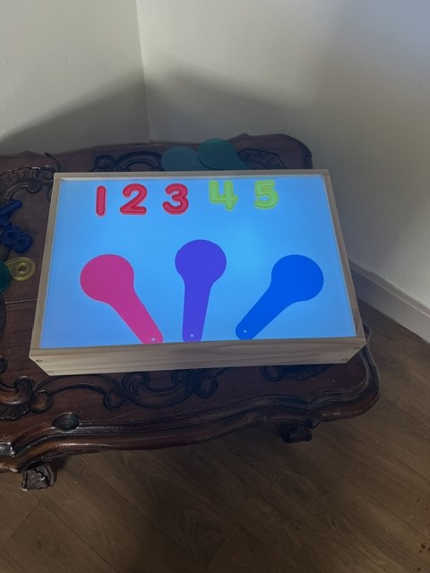
Every year we work hard to evaluate our practice, our environment and our relationships with children and their families. With this in mind we have 3 set priorities we work on every year which are identified from our self-evaluation and feedback forms from our families.
In 2025 to 2026 our priorities were to:
- Ensure all children are making good progress in mathematics and numeracy. We can see from the children's tracking that almost all children are making good progress with mathematics and numeracy in the nursery class. Our process for tracking changed and now we send home children's priorities termly, the feedback we have received has been positive and impactful. Staff carried out termly audits of the resources and how they were supporting children's learning, this informed us of our next steps, overall, this has been very successful, and we intend to continue with this. Key workers have termly meetings with Donna to review the child's developmental milestones tracker. Their tracked learning is observed and shared on learning journals, which supports us to identify areas we would like to support children in, ensuring we can be proactive and engaging with this learning. These are then shared with parents termly with suggestions on how the priorities can be supported at home. We are also very keen for parents to share their ideas and observations with us. If you have any comments, suggestions around this please let me know.
- To support all children with focus on emotional wellbeing - We can see through observations taken of all children there was a clear focus with this, and clear progression was made for most of the children. In term one 44% of the children were managing their relationships, emotions and day to day challenges. By term 3 this has increased to 95%. Staff attended training, resources where purchased, and environments adapted to meet the children's interests and emotional wellbeing. This will continue to be a strong focus for 2026/27.
- Children's voices are used to inform planning and next steps; Children's rights are evident and impactful for all - Through observations and discussions with children we ensure their voice is impacting our planning. Staff share the children's big ideas which are displayed in the playroom. These can be comments, conversations or questions the children may have and staff support them to explore and learn. We have explored several of the articles from the children's charter with staff, parents and children looking at how our practice, policies and procedures and everyday life supports these to be embedded.
This year’s priorities 2026 - 2027 will be:
- To support all children with focus on wellbeing: support transitions and changes. Ensure our environment supports all of this.
- Ensure all children are making good progress in mathematics and numeracy.
- Children's voices are used to inform planning and next steps. Children's rights are evident and impact all.
These may change as we progress with observing what is working and what could be better, linking to the new Quality framework document.
Throughout the year we will be inviting you to share your thoughts on these and how you see them impacting practice and your child's learning.

We look forward to working with you all to support quality within our nursery setting.

Social Media
We currently have a Facebook business page and are on X. As well as this we have our webpage which includes of updates and relevant information please take some time to explore.
Please join us on our social media platforms:
http://smilechildcare.org
https://www.facebook.com/smilechildcareedinburgh/?locale=en_GB

Staff news

We would like to welcome back Tina. Tina previously worked in our under 3 setting before going off on maternity leave. Please say hello when you meet her.

Eco-Schools - We did it!
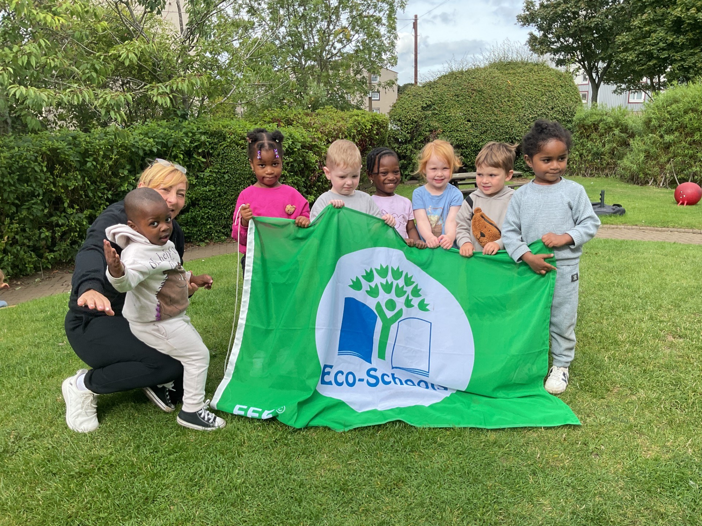

We are so excited to share with you all that smilechildcare have achieved their 7th Eco Green Flag. We are delighted to have retained this accreditation for 14 years. The children and staff work hard over a range of topics including Litter, Recycling and bio-diversity to achieve this. We are beginning to complete our next environmental review which will highlight the next areas we would like to learn about and develop.
To see some of the work the children have been doing please highlight the link and go to the SWAY
https://sway.cloud.microsoft/X4DLnkdoTMlD7oNB

Wet or soiled clothing- spare clothing and indoor shoes

We kindly ask parents at the end of each day to check the box situated at the front door and collect any wet or soiled clothing that day.

We would also like to remind parents to ensure your child has at least 1 full change of clothing that is kept at nursery and replaced when used.
As we are coming into the wetter days, could you please provide a pair of indoor shoes/slippers for your child. Please ensure they are named.

We look forward to a fun term with lots of learning, curiosity and challenge.
If you have any skills or interests, you would like to support the nursery with please let us know.
- Read a story to the children in your home language
- Gardening/ planting and growing
- play a musical instrument or dancing
We would love to share these with the children.

Donna and all the smilechildcare team

