ELCC Menu
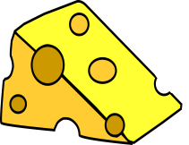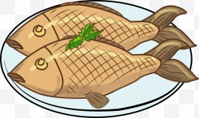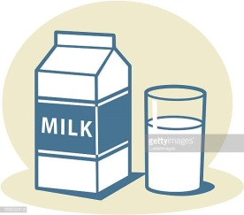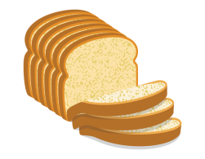

Week 3 | Monday | Tuesday | Wednesday | Thursday | Friday
Breakfast | Selection of cereals, toast fresh fruit & natural yoghurt  Gluten/Dairy | Selection of cereals, toast fresh fruit & natural yoghurt  Gluten/Dairy | Selection of cereals, toast fresh fruit & natural yoghurt  Gluten/Dairy | Selection of cereals, toast fresh fruit & natural yoghurt  Gluten/Dairy | Selection of cereals, toast fresh fruit & natural yoghurt  Gluten/Dairy
Lunch | Fish fingers with mashed potato & mixed seasonal veg  Wheat/Fish  Banana bread  Wheat | Chicken pasta bake with hidden veg  Wheat  Melon assortment | Sausage & chunky veg casserole with baby potatoes  Wheat  Yoghurt  Dairy | Beef lasagne with garlic bread & salad  Wheat/Dairy  Fresh fruit platter | Lentil & sweet potato curry with naan bread & rice  Wheat/Celery/Celeriac  Fruit scone  Wheat/Dairy
Vegetarian Lunch | Fishless fingers with mashed potato & mixed veg  Wheat  Banana bread  Wheat | Pasta bake with hidden veg  Wheat  Melon assortment | Veggi sausage & chunky veg casserole with baby potatoes  Wheat  Yoghurt  Dairy | Veggi lasagne with garlic bread & salad  Wheat/Dairy  Fresh fruit platter | Lentil & sweet potato curry with naan bread & rice  Celery/Celeriac  Fruit scone  Wheat/Dairy
Afternoon snack | Homemade ham & cheese scones with finger crudities  Wheat/Dairy  Fruit | Homemade vegetable soup with crusty bread & butter  Wheat/Celery/Celeriac  Fruit | Mixed meat, cheese & crudity platter with pitta pockets  Dairy/Wheat  Fruit | Potato & broccoli gratin  Wheat/Dairy  Fruit

