ELCC Menu
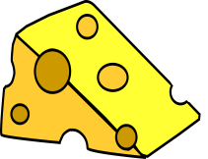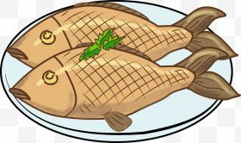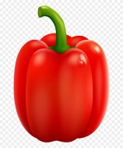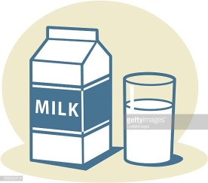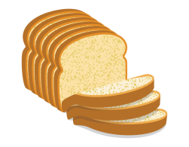

Week 1 | Monday | Tuesday | Wednesday | Thursday | Friday
Breakfast | Selection of cereals, toast fresh fruit & natural yoghurt  Gluten/Dairy | Selection of cereals, toast fresh fruit & natural yoghurt  Gluten/Dairy | Selection of cereals, toast fresh fruit & natural yoghurt  Gluten/Dairy | Selection of cereals, toast fresh fruit & natural yoghurt  Gluten/Dairy | Selection of cereals, toast fresh fruit & natural yoghurt  Gluten/Dairy
Lunch | Macaroni cheese with mixed veg  Dairy/Wheat  Yoghurt  Dairy | Beef mince potatoes & broccoli  Fresh fruit platter | Roast dinner with mash potato mixed veg stuffing & gravy  Wheat  Chocolate & raspberry sponge  Wheat/Egg | Sweet potato & lentil curry with boiled rice & naan bread  Wheat  Fresh fruit platter | Vegetable soup with mixed sandwiches  Wheat/Dairy  Yoghurt  Dairy
Vegetarian Lunch | Macaroni cheese with mixed veg  Dairy/Wheat  Yoghurt  Dairy | Quorn mince potatoes & broccoli  Egg  Fresh fruit platter | Quorn dinner with mash mixed veg stuffing & gravy  Egg  Chocolate & raspberry sponge  Wheat/Egg | Sweet potato & lentil curry with boiled rice & naan bread  Wheat  Fresh fruit platter | Vegetable soup with mixed sandwiches  Wheat/Dairy  Yoghurt  Dairy
Afternoon snack | Bagels with ham, cheese  cucumber & carrot sticks  Wheat/Dairy  Fruit | Pesto pasta salad  Wheat/Dairy  Fruit | Carrot & sweet potato soup with crusty bread  Celery Celeriac Wheat  Fruit | Mixed meat platter with wraps and crudities  Wheat/Dairy

ELCC Menu 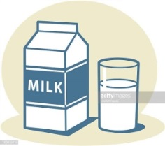

Week 2 | Monday | Tuesday | Wednesday | Thursday | Friday
Breakfast | Selection of cereals, toast fresh fruit & natural yoghurt  Gluten/Dairy | Selection of cereals, toast fresh fruit & natural yoghurt  Gluten/Dairy | Selection of cereals, toast fresh fruit & natural yoghurt  Gluten/Dairy | Selection of cereals, toast fresh fruit & natural yoghurt  Gluten/Dairy | Selection of cereals, toast fresh fruit & natural yoghurt  Gluten/Dairy
Lunch | Tomato mascarpone & spinach tagliatelle  Wheat/Dairy  Fruit sponge | Roast beef with gravy, baby potatoes & cabbage  Mixed fruit platter | Chicken curry with rice & naan bread  Wheat/Celery/celeriac  Yoghurt  Dairy | Fish mornay with baby potatoes and broccoli  Fish/Wheat/Dairy  Ice Cream  Dairy | Chicken noodle soup with mixed sandwiches  Egg/Wheat/Dairy  Yoghurt & fruit  Dairy
Vegetarian Lunch | Tomato mascarpone & spinach tagliatelle  Wheat/Dairy  Fruit sponge | Quorn with gravy, baby potatoes & cabbage  Egg  Mixed fruit platter | Quorn curry with rice & naan bread  Wheat/Celery/Celeriac  Melon assortment | Fishless mornay with baby potatoes and  Wheat/Dairy  Ice Cream  Dairy | Quorn noodle soup with mixed sandwiches  Egg/Wheat/Dairy  Yoghurt & fruit  Dairy
Afternoon snack | Vegetable soup with crusty bread & butter  Wheat/Dairy  Fruit | Jacket potato with tuna, cheese, beans  Fish/Dairy  Fruit | Mixed pizza slices  Wheat/Dairy  Fruit | Beans on toast  Wheat  Fruit

